Making a Class Weebly
Visit Maria Begin’s Prezi on creating a Weebly@ http://prezi.com/rbk81x54rwgg/sign-up-for-weebly/
Visit Weebly.com and create an account.
Do not sign up with Facebook, or you will not be able to access at school

Choose Site and Select Theme
Plan website – complete steps and watch videos along the way.
Make sure you print goals so you can have something to guide you.
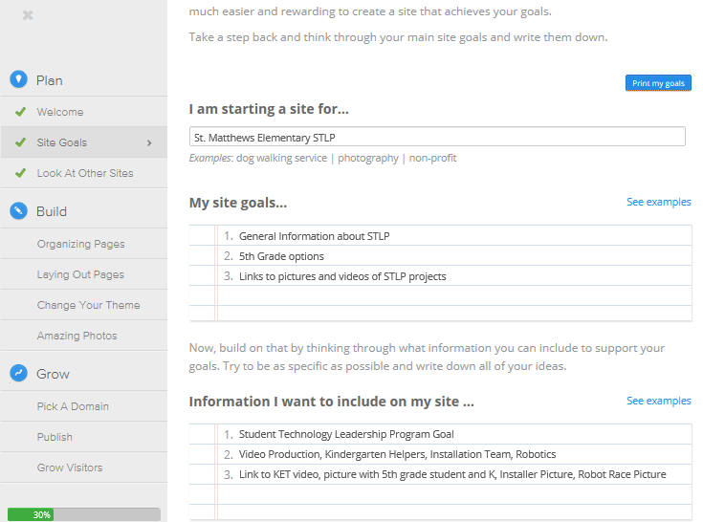
Once complete start building your website by clicking the design tab.
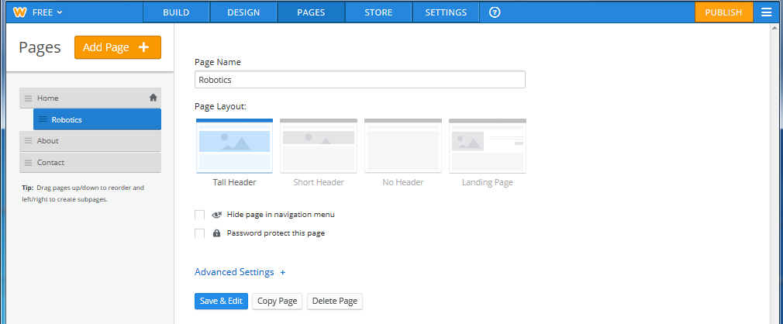
Click Pages tab and Add Page to create more pages.
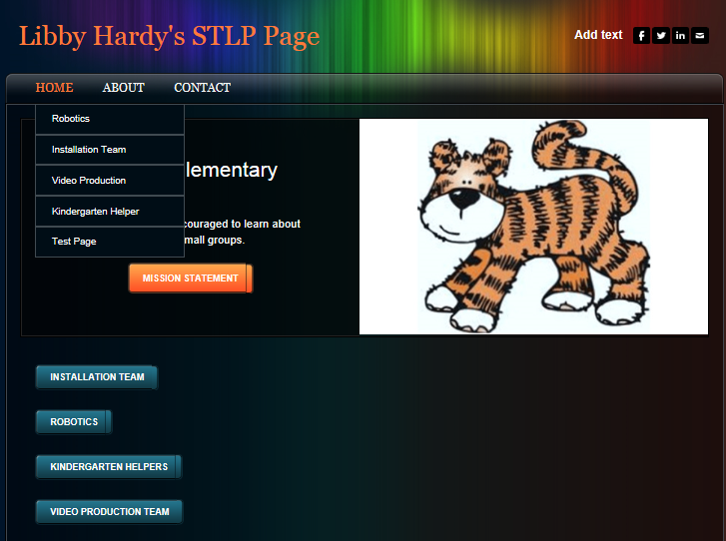
Drag page slightly to the right as shown and buttons will be available from the lead page. Here is how my home page looks.

Once you have pages set up, edit each page by adding pictures and text.
The first picture I set was the banner. I decided so that the pages would have a common feel to have this cute tiger on all pages.

Next I started adding elements like text, pictures and slideshows.
Don’t forget to add information to your About and Contact pages.
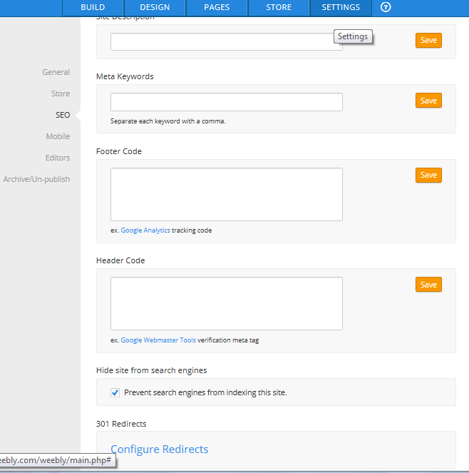
Working in an elementary school environment, I chose not to have keywords and to prevent search engines from indexing this site. I only want people who know the web address to be able to find it. Obviously if it were a commercial site I would want it out where people could find it.
Remember changes don’t take effect until you publish.
Tips:
Visit these sites for clipart and note copyright policy:
http://classroomclipart.com/CRCLcopyright.htm
http://www.thistlegirldesigns.com/shop/conditions.php?osCsid=02038eaeb5e0e66c4889376acf9b2683
http://www.techradar.com/us/news/internet/web/12-best-places-to-get-free-images-for-your-site-624818
http://www.teachingcopyright.org/resources
http://www.freetech4teachers.com/2011/06/9-places-to-find-creative-commons.html#.U31eR_ldXy4
Check out these Weeblys
http://www.mcfcomputers.weebly.com/
http://mrshardylab.weebly.com/
http://MrsSpurlock.weebly.com/

